**NIC Teaming**

**Difference between Bridged and Teaming:**

Bridged mode is a simplified version of teaming. In a nutshell all bridging does is allow the computer to see both network connections as 1, and use the bandwidth of both at the same time. It's also the only "teaming" type option available on non-server OS's.

Teaming is more geared towards throttling and stability. Normally teaming is setup so that 1 line is in, and 1 line is out. This prevents the server from being over-run with too much incoming traffic such that the outgoing suffers, and vice-versa.

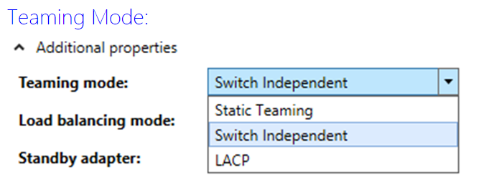

You can configure your team for either Static Teaming, Switch Independent, or LACP (Link Aggregation Control Protocol).

**Static Teaming** requires configuration on the switch and the computer to identify which links form the team. Because this is a statically configured solution. This is a switch dependent mode of NIC teaming.

**Switch Independent mode** allows you to distribute the NICs in your team across numerous Network Switches in your environment.

**LACP** provides the Link Aggregation and allows for the expansion and reduction of the NIC team. This is a switch independent mode of NIC teaming.

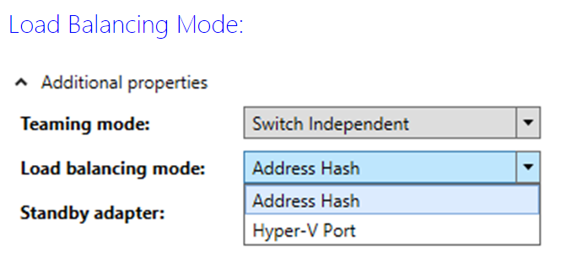

**Address Hash** is how you configure your team to load balance network traffic between the NICs in the team.

**Hyper-V Port** load balancing will load balance your traffic by VM. With Hyper-V Port, the good news is that each VM will transact on a separate NIC, but the down side is that each VM will only transact over a single NIC.

If you have multiple virtual NICs in your VM and they are teamed, the Hyper-V Port may be the best choice. For most configurations, I expect that the Address Hash will be your best choice to allow your VM to still access the network in case the NIC the VM is utilizing fails. Remember that with Hyper-V Port the failure of the NIC the VM is utilizing disrupts communication between the VM and the network. Address Hash won’t have this problem